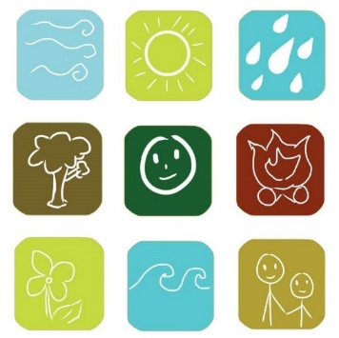

Elements Nature Based Play - Have your children active & imaginative amongst nature. Think huts, trees, tools, arts n crafts, plenty of time and space. Elements has a great mix of planned experiences and play throughout our programmes. For the spring holidays Elements are offering themes such as ‘Heroes in the Wild’, ‘Mini Fairy Gardens’, on a Cashmere Rd farm. Or ‘Water & Wheels’ Lincoln, ‘Taking Flight’ Marshlands. Ages 5-13yrs.

See our website https://www.elementsnature.co.nz/ or facebook page https://www.facebook.com/elementsprogrammes/ to see what we get up to. Bookings are through https://elements.aimyplus.com
For more info email elementsprogrammes@gmail.com

