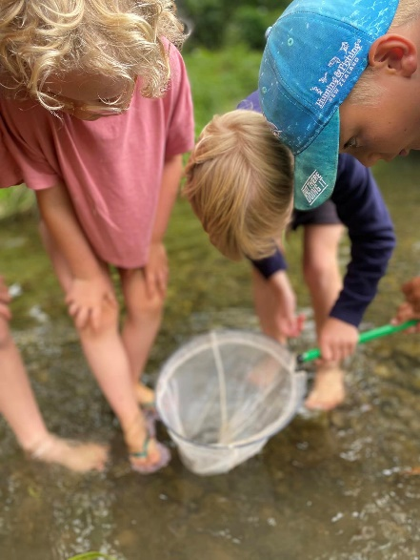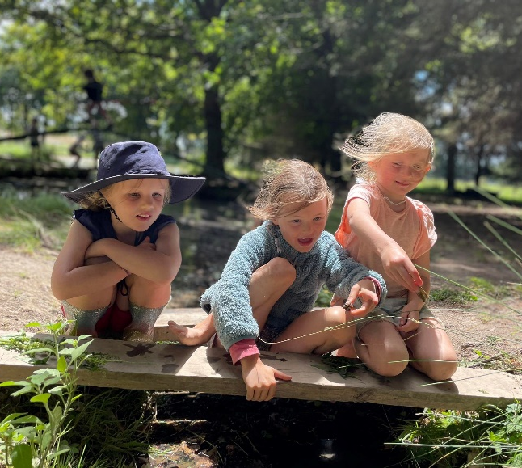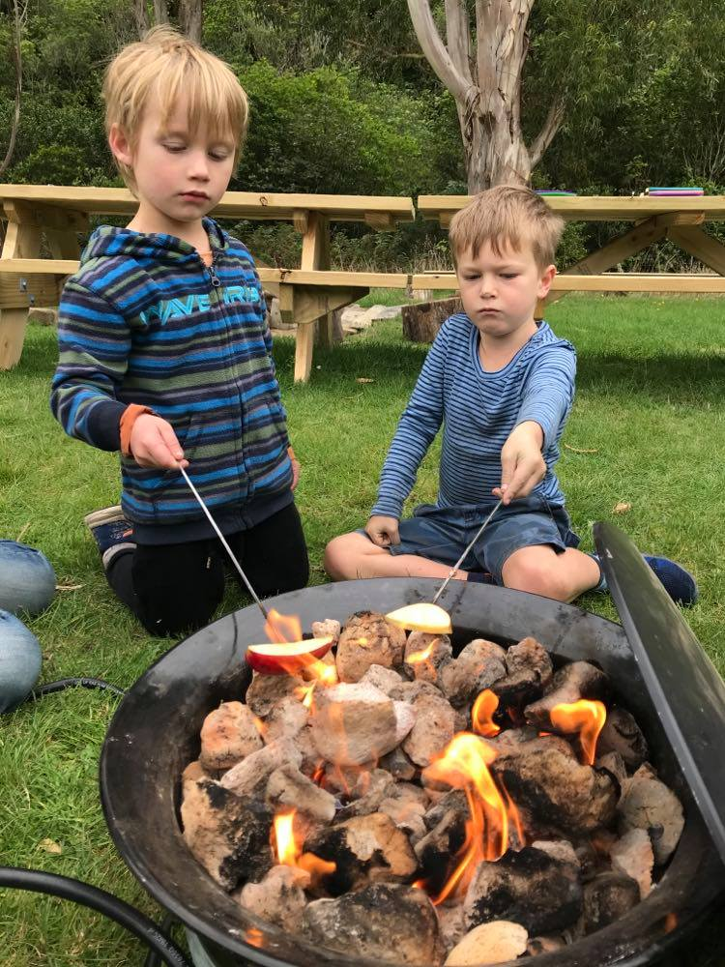




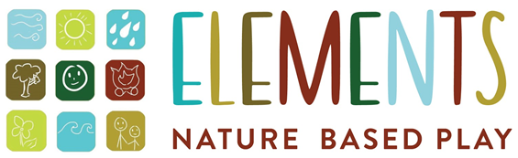
30 Sept-4 Oct
7 Oct – 11 Oct
Cashmere / Halswell
Lincoln
Marshlands
Elements provides a truly authentic outdoor experience for children. Elements is no ordinary programme as we consider how the environment helps the developing child learn & grow. Active movement, creative play & fun! Explore in the bush, creek, climb trees, group games in open spaces, or challenge your construction skills by making huts & - plenty of opportunity for imagination. These spring holidays Elements are offering a range of programmes at Lincoln, Marshland and on a Cashmere/Halswell farm including:
- Heroes in the Wild!
- Mini Fairy Gardens
- Adventure Race Day
- Water n Wheels
Register now for the spring holidays

Website: https://www.elementsnature.co.nz/
Fb: https://www.facebook.com/elementsprogrammes
To book: https://elements.aimyplus.com/
Email: elementsprogrammes@gmail.com
Phone: Kim 027 9340409

5-13 years

