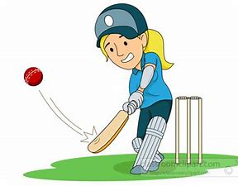
GIRLS CRICKET – ONE OF THE FASTEST GROWING SPORTS
Parents – consider your daughter playing cricket this season in an all girls grade this summer.
Saint Albans Cricket Club has all girls teams in the following grades:
Girls Year 2/3/4 : Mini Introduction cricket
Girls Year 5/6 : played Saturday morning 9-11am
Girls Year 7/8 : played Saturday morning 9-1130am.
It’s QUICK –games last between 1- 2.5 hours
It’s FUN – the girls play in an all girls grade and everyone gets a chance to bat and bowl every game
It’s CHEAP – no expensive gear needed – the club supplies it all including shirts and caps.
COVID – If you have lost your job due to Covid – we are offering some free places in cases of genuine hardship or half priced subs.
Our season starts in October and we are now taking registrations for junior girls in years 2-8.
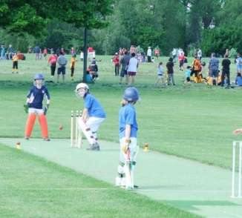
Why saints ? We are the only club in the South Island with 2 NZ White Ferns, we have top Canterbury and NZ level women coaches, and we are 100% focused on growing the number of girls playing cricket for fun or competitively.
For more information see : www.stalbanscricket.co.nz or www.sporty.co.nz/girlscricket
If interested call/text/email
- Barry : 027 535 6245 or barryvb@stalbanscricket.co.nz
- Matthew : 027 696 1010 or matthewd@stalbanscricket.co.nz

