NATIONAL ORAL HEALTH MONTH
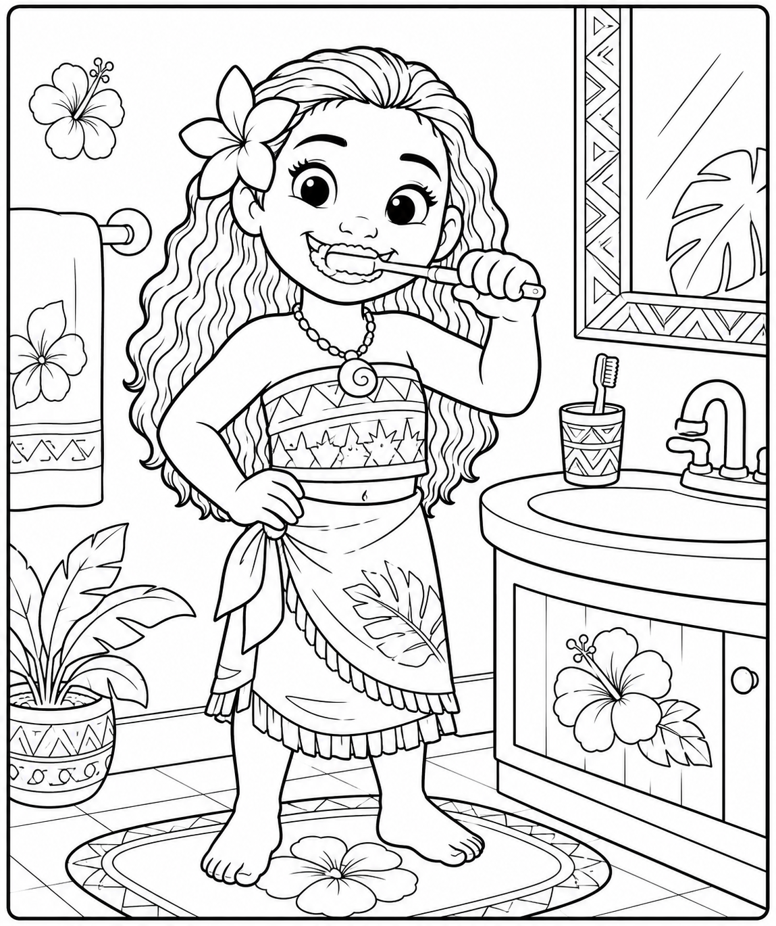

Name: _______________________________________________________

School: _______________________________________________________

Email: ________________________________________________________


Room: _____________________

Age: _______________________

