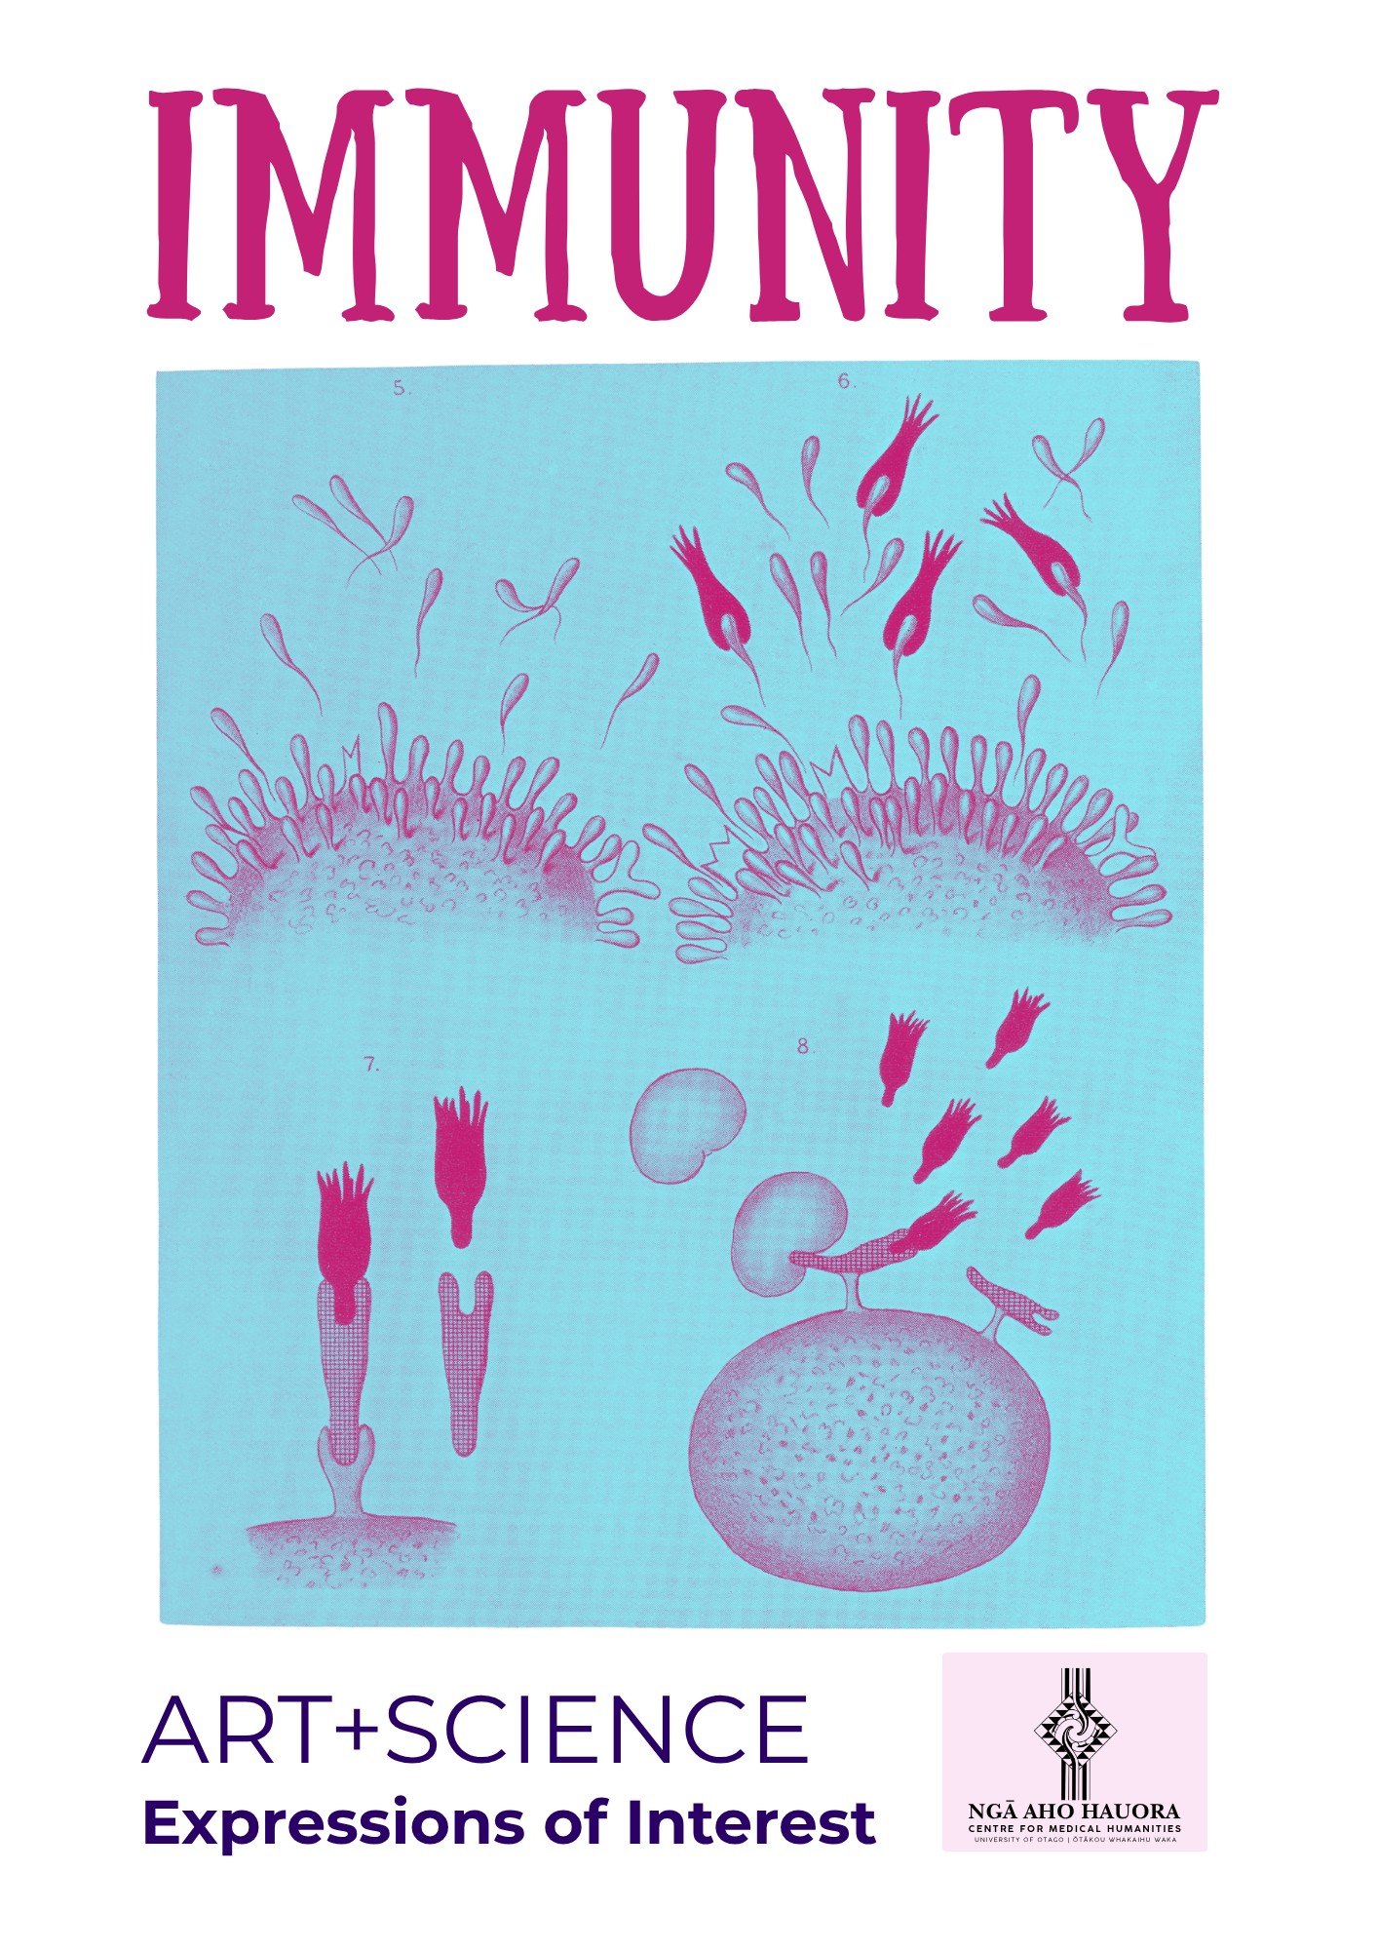

Our theme for the next Art+Science exhibition, in 2027, will be IMMUNITY. The exhibition is being sponsored by Ngā Aho Hauroa | Centre for Medical Humanities.

Immunity is not simply defence; it involves recognition and memory, exposure and response, adaptation and change. What protects can also harm.

The term ‘immunity’ originated in ancient Roman law, describing an individual’s exemption from duties. In medieval Europe it referred to the Church’s remove from civil control. When scientists in the late 19th century needed a word to describe the body’s resistance to disease, they borrowed this legal-political term of exclusion. As the study of immunology developed, so too did considerations of the rhetorical power of discourses of immunity. When Frank Macfarlane Burnet won the Nobel Prize in 1960 for his work on acquired immune tolerance, his acceptance speech acknowledged his work’s debt to the humanities: ‘immunology’, he explained, ‘has always seemed to me more a problem in philosophy than a practical science’.

Immunity has always been embedded in the arts’ questioning of the nature of the self and of society. To study immunity is to trace borders and their permeable limits, to assess threats and responses to contaminants, and to gaze at the parts of our world that exist beyond the visible.

ART+IMMUNITY
There are many ways into this theme, from the cellular and microbial to the ecological, social, historical and deeply personal.

Bodies and boundaries:
Innate and adaptive immunity, inflammation, immune memory, autoimmunity, allergy, immunodeficiency, recognition and misrecognition, self and other.

Microbes, evolution and environment:
Microbiomes, pathogens, symbiosis, mutation, resistance and adaptation; biodiversity, pollution, climate change, emerging disease and ecological health.

Women, ageing and immunity:
Ovaries, menopause, hormones, inflammation, reproductive health and emerging research into the immune functions of the post-menopausal body. What might this reveal about ageing and the assumptions that have shaped medical knowledge?

Collective immunity, health and society:
Vaccination, contagion, quarantine, public health, trust and shared vulnerability. In Aotearoa, the histories of the 1918 influenza pandemic, polio and rubella remain part of our collective memory. Before rubella vaccination, congenital rubella syndrome resulted in generations of children born with blindness and deafness and contributed to the development of specialist educational and support services. Vaccination changed that landscape.

Concepts of difference
Varied resistance and vulnerability across communities, immunology’s historical connections with eugenics and social engineering, body politics and necropolitics.

Language of immunity
Metaphors connecting immunological processes to the military (attacking the invader, defending the self), to technology (bio-hacking the immune system), to consumerism (purchasing supplements), to politics (unwanted others), to contagion (the self under threat). Visual metaphors, during the Covid19 pandemic, of bubbles, boats, a ‘team of five million’ and goals of ‘flattening the curve’.

The interdisciplinary field of medical humanities offers a pathway into all of these questions: bringing illness, disability, lived experience, medical history, ethics, culture, narrative, and the arts into conversation with scientific knowledge
Expressions of interest

The programme works through a partnership between scientists/researchers and artists, who converse together about their work, so that new artistic work can be produced.

We are now seeking:
- scientists and other academic researchers, connected directly or indirectly to Ngā Aho Hauora | Centre for Medical Humanities, whose work connects to immunity and who might want to participate.
- artists and creative practitioners connected to the Centre. As always, we are interested in artists responding to research rather than simply illustrating it, and in what can emerge when different ways of knowing meet.

If you are interested, please let us know your area of expertise or where you see a connection to the theme. There are a limited number of places for both, but if you get in touch to express your interest (via our email, at centreformedicalhumanities@otago.ac.nz) we can share more information about the timeline and process from there.

We look forward to hearing from you if IMMUNITY sparks an idea for you!

