St Thomas’s Mobile Phone Policy

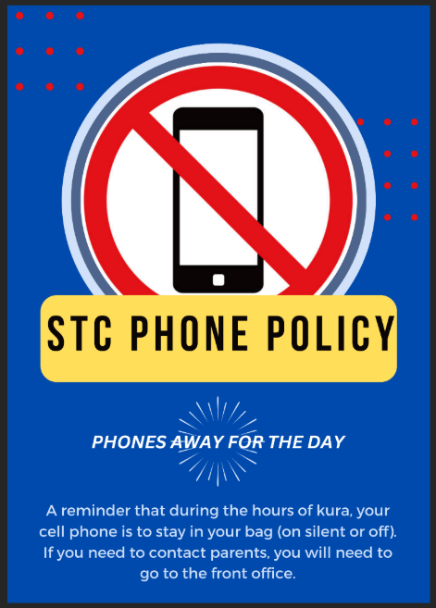
New Government regulations require that schools must ensure students do not use or access a phone while they are attending school, including during lunch time and breaks. The Government has introduced regulations that require all state and state-integrated schools to put in place school rules regarding mobile phones.
International research indicates that cell phones in schools are not conducive for learning and for student wellbeing. Therefore, these rules are designed to ensure that the learning of all students is maximised, while minimising any potential for distraction and cyber-bullying.
It is important to note that if students do make the decision to bring a mobile phone to school, they do so at their own risk. The school is not responsible for any loss or damage caused to any mobile phone.

What are the rules?
The regulations require that schools must ensure students do not use or access a phone while they are attending school, including during lunch time and breaks. This includes students who are on a school course or visit outside the school grounds.
The new rules allow students to use or access a phone in certain circumstances including:
- a phone is needed for health reasons (for example, to monitor insulin levels); or
- a phone is needed to help a student with a disability or learning support need (for example, to assist with impaired communication); or
- a teacher requires students to use phones for a specific educational task or purpose (for example, for a class assignment)
STC Phone Policy?
If a student is seen using a phone during school hours, then they will be asked to put it away. If there is refusal or continual phone use, then the pastoral team will respond. Following this further use or continual issues will require a parent level meeting to discuss phone use and the law and come up with and supportive plan.
Please support the school in implementing the ministry of educations requirements.

