CELEBRATING A NEW CHAPTER AT
ANDERSONS BAY SCHOOL

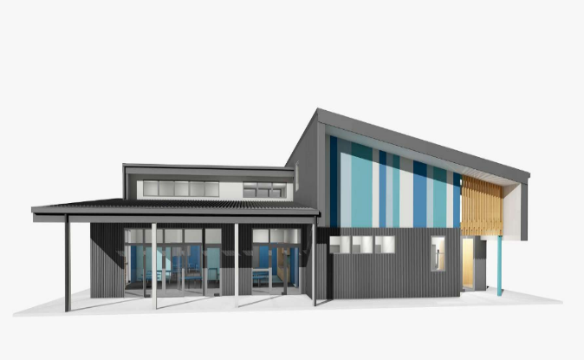

We warmly welcome
- Past students and families
- Current students and families
- Current and past staff members
- Our wider community

This will be a fantastic opportunity to celebrate our long history on this site dating back to 1858 and to reconnect with old friends and classmates. It is also an opportunity to celebrate the present and the new initiatives that having a purpose built facility allows.

We are delighted to have one of our oldest past pupils from 1935 cutting the ribbon for our new hall alongside our oldest current student.

Date: Monday, 29 June 2026
Time: 4pm – 6pm
Address: 92 Jeffery Street, Andersons Bay, Dunedin

If you have mobility needs and require a parking space please contact the school office:
Phone: (03) 454 4413
Email: admin@andybay.ac.nz

