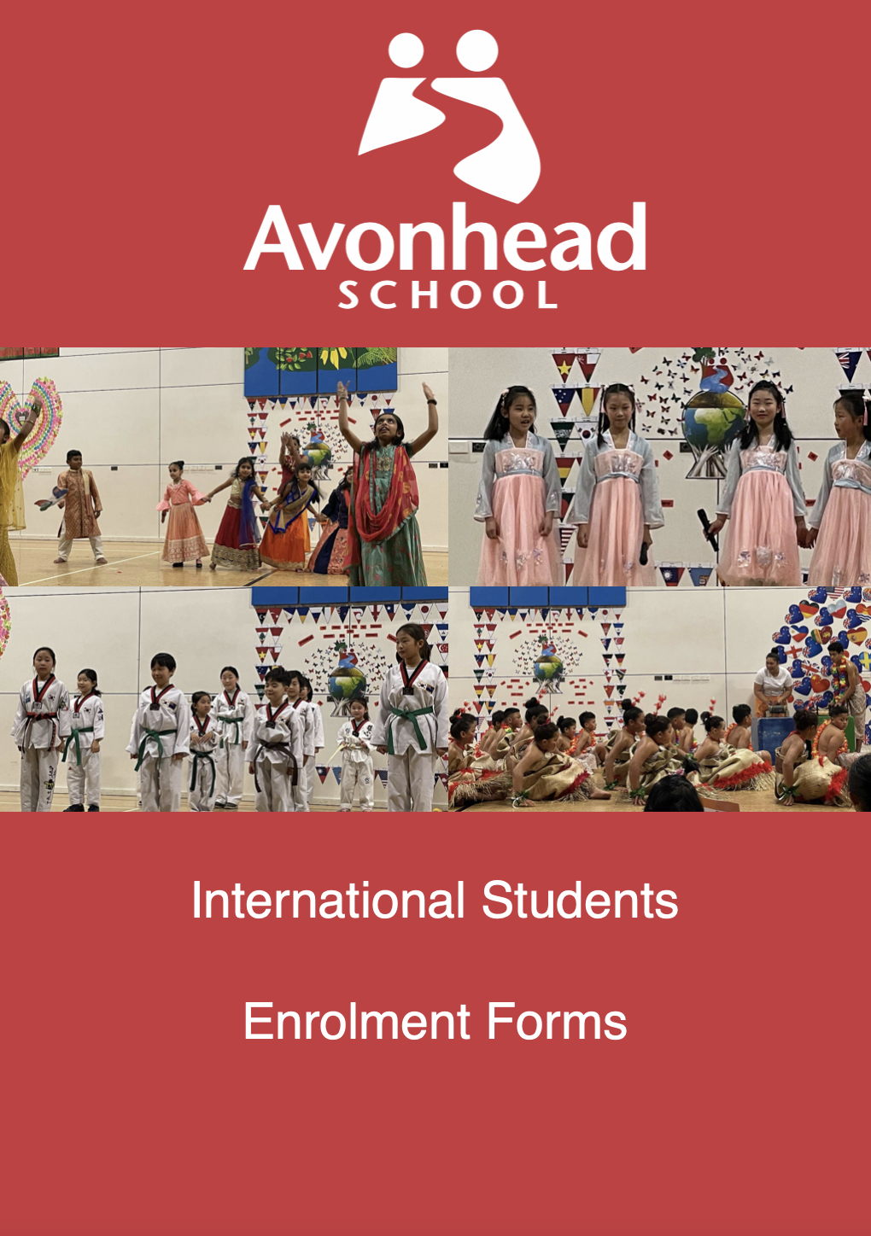

Avonhead School
55 Avonhead Road
Christchurch 8042
New Zealand

Phone: +64 3 348-7361
Email: admin@avonhead.school.nz

APPLICATION FOR ENROLMENT AS AN INTERNATIONAL STUDENT – You can print this off or fill it out on Word (in the white spaces) and email it back.
PART ONE
FAMILY NAME | DATE OF BIRTH
FIRST NAMES | EUROPEAN NAME (IF ANY) | BOY/GIRL
COUNTRY OF BIRTH: | ETHNIC GROUP:
PASSPORT – COUNTRY OF ISSUE | PASSPORT NUMBER
PERIOD OF INTENDED STAY (eg - 2 terms, full year)
DATE OF ARRIVAL | EXPECTED DATE OF DEPARTURE
NZ ADDRESS: | NAME OF PARENT/S WHOM THE CHILD WILL BE LIVING WITH
………………………………………………………………………………………..  ………………………………………………………………………………………..  ………………………………………………………………………………………. | ………………………………………………………………………………………..  ………………………………………………………………………………………..  ………………………………………………………………………………………..
HOME PHONE NUMBER: | WORK PHONE NUMBER (if applicable)
CELLPHONE NUMBER: | EMAIL ADDRESS IN NZ
NAME OF EMERGENCY CONTACT (OTHER THAN PARENT LIVING IN NZ) | EMERGENCY CONTACT NUMBER
RELATIONSHIP TO STUDENT:
LANGUAGE SPOKEN AT HOME | IF WE NEED TO CONTACT YOU AT HOME, ARE WE ABLE TO SPEAK TO YOU IN ENGLISH?
MEDICAL AND TRAVEL IN SURANCE DETAILS (Medical and travel insurance is compulsory for international students coming to NZ)

PART TWO
AVONHEAD SCHOOL EXPECTS TO BE ABLE TO MEET THE LEARNING NEEDS OF CHILDREN ENROLLED AT THE SCHOOL. DOES YOUR CHILD HAVE ANY LEARNING OR BEHAVIOURAL NEEDS?
HAS YOUR CHILD BEEN AT ANY OTHER SCHOOL (OR PRE-SCHOOL) BEFORE COMING HERE? | EUROPEAN NAME (IF ANY) | BOY/GIRL
LEVEL OF ENGLISH – WHAT IS YOUR ESTIMATE OF YOUR CHILD’S LEVEL OF ENGLISH. PLEASE TICK or write yes alongside the box
- PRE-BEGINNER (does not speak in English at all) 
- BEGINNER (knows a few English words) 
- ELEMENTARY (is able to understand and speak using simple English sentences) 
- INTERMEDIATE (is able to understand and speak English reasonably well) 
- FLUENT (is fluent in speaking and listening in English 

WHAT SPORT DOES YOUR CHILD PLAY?  PLEASE PROVIDE DETAILS…. | DOES YOUR CHILD SING OR PLAY ANY MUSICAL INSTRUMENTS?  PLEASE PROVIDE DETAILS…….
………………………………………………………………………………………..  ………………………………………………………………………………………..  ………………………………………………………………………………………. | ………………………………………………………………………………………..  ………………………………………………………………………………………..  ………………………………………………………………………………………..
WHAT ARE YOUR CHILD’S INTERESTS OR HOBBIES?
WHAT ARE YOUR CHILD’S ACADEMIC STRENGTHS (eg mathematics, science)
WHAT ARE HIS OR HER ACADEMIC WEAKNESSES THAT HE/SHE WILL NEED SOME HELP IN?
PART THREE
DECLARATION
- I CONFIRM ALL THE INFORMATION CONTAINED IN THIS APPLICATION IS TRUE AND CORRECT TO THE BEST OF MY KNOWLEDGE AND BELIEF
- I WILL INFORM THE SCHOOL IF THERE ARE ANY CHANGES TO THE DETAILS OF THIS APPLICATION

PARENT/S SIGNATURE………………………………………………………………………………………………………………………………………

DATE……………………………………………………………………

Checklist for International Students
1 | Passport  Passport Number: | Yes / No
2 | Medical Insurance  Policy Number:  Cover from: to | Yes / No
3 | Current Academic Report shared with the school | Yes / No
4 | Enrolment Form Completed and Checked | Yes / No
5 | Student or Visitor Visa issued  Student Visa Number:  Date of Expiry: | Yes / No
6 | Visitor’s/Guardian’s Visa issued to:  Date of Expiry: | Yes / No

