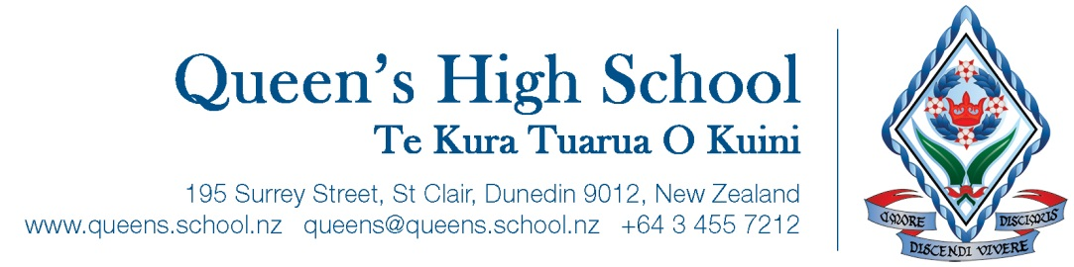

Friday 13 August 2021

Health and well-being presentations from ‘Attitude’

Kia ora koutou
On Friday 20 August all students will be receiving presentations from the youth health organisation, ‘Attitude’.
Period 1 | Year 10 | Sex with Attitude  This presentation looks at relationships and the emotional and social aspects of sexuality.
Period 2 | Year 9 | Connected  Helps young people reflect on how technology influences their lives. The presentation encourages them to become positive cyber citizens and to seek a healthy balance between the online and offline worlds. Text bullying, online addiction and cyber safety are covered.
Period 4 | Seniors | Choices, resilience, and self-esteem  This presentation offers practical advice on how to get through the hard chapters of life and delivers the ‘life messages’ teenagers need to grow mental and emotional resilience. It covers the importance of making positive decisions, and how to build the four cornerstones of a meaningful life.

Please follow the link for more information about what is covered in these presentations: https://www.attitude.org.nz/
If for any reason you DO NOT want your daughter to attend any of the above presentations please email me, or your daughter’s year level dean.
Ngā mihi

Jacqui Earland
Learning Area Leader Health and Physical Education
jacquie@queens.school.nz


